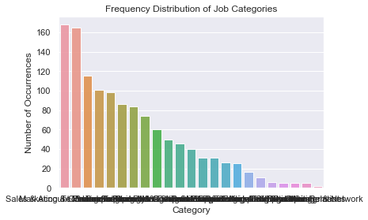

From the above graph we can conclude that “Sales &Marketing” Jobs are 160 times more than the network related jobs in the market at any given point of time. Thus, giving us a general idea, which job skills are more in demand in comparison to others.

Using Random Forest ML algorithm for the Job Skills dataset, we see that RMS(Root Mean Squared Value ) for different values n_estimators first decreases and then increases thus, the graph for RMS resulting in a parabola.

As you can see in the below image

|  |  |
| --- | --- |
| **N_Estimators** | **RMS** |
| 20 | 199.0444 |
| 200 | 193.9017 |
| 400 | 194.2553 |

Upon analysing the above table, we can safely assume that for the value of n=20 the model is underfitting and for the value of n=400 the model has become overfitted thus, increase in the value of RMS.

Thus, we can safely assume that for a balance Model the value of **200 < n< 400.**

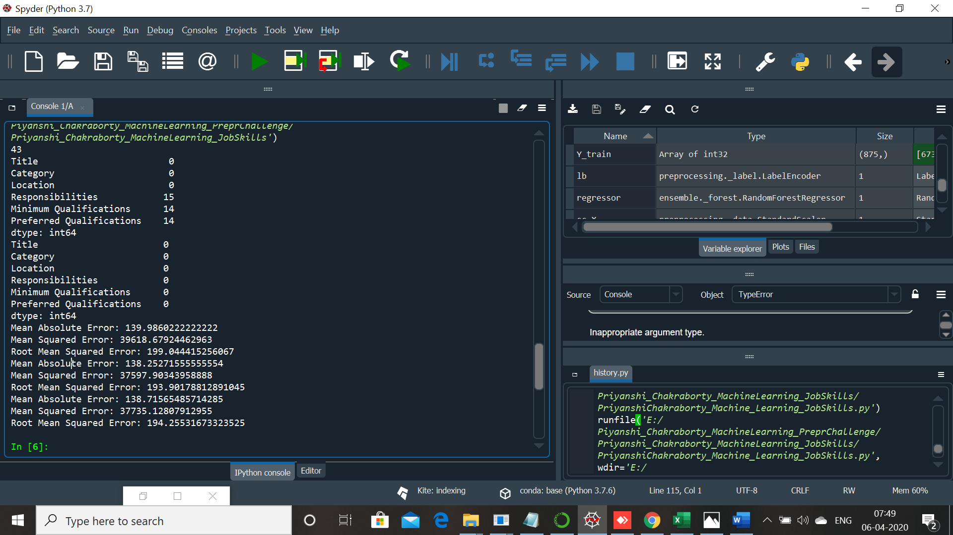

Now, when I applied Feature Ranking to the attributes, we see no major or minor contributions as of such but based on the graph and values we can say that the 2 most influencing factors are Job Category and Job Location.

